# Experiment : 10

**Aim:** Write a Program to implement Dijkstra‘s algorithm to compute the Shortest path through a graph.

**Program:**

#include<stdio.h>

#include<conio.h>

void main()

{

int path[5][5],i,j,min,a[5][5],p,st=1,ed=5,stp,edp,t[5],index;

printf("enter the cost matrix\n");

for(i=0;i<5;i++)

for(j=0;j<5;j++)

scanf("%d",&a[i][j]);

printf("enter the paths\n");

scanf("%d",&p);

printf("enter possible paths\n");

for(i=0;i<p;i++)

for(j=0;j<5;j++)

scanf("%d",&path[i][j]);

for(i=0;i<p;i++)

{

t[i]=0;stp=st;

for(j=0;j<5;j++)

{

edp=path[i][j+1];

t[i]=t[i]+a[stp][edp];

if(edp==ed)

break;

else

stp=edp;

}

}

min=t[st];

index=st;

for(i=0;i<p;i++)

{

if(min>t[i])

{

min=t[i];

index=i;

}

}

printf("minimum cost %d",min);

printf("\n minimum cost path ");

for(i=0;i<5;i++)

{

printf("--> %d",path[index][i]);

if(path[index][i]==ed)

break;

}

getch();

}

**Output:**

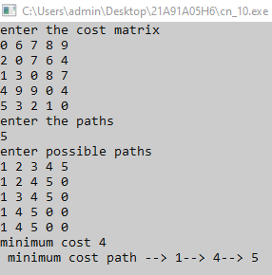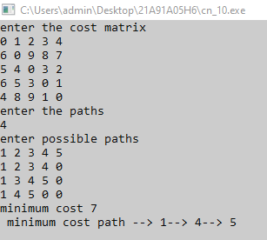

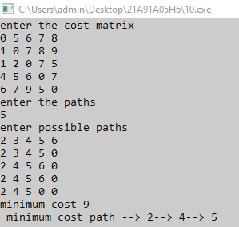

**Experiment: 11**

**Aim:** Write a Program to implement Distance vector routing algorithm by obtaining routing table at each node (Take an example subnet graph with weights indicating delay between nodes).

**Program:**

#include<stdio.h>

#include<conio.h>

struct node

{

unsigned dist[20];

unsigned from[20];

}rt[10];

void main()

{

int dmat[20][20];

int n,i,j,k,count=0;

printf("\nEnter the number of nodes : ");

scanf("%d",&n);

printf("Enter the cost matrix :\n");

for(i=0;i<n;i++)

{

for(j=0;j<n;j++)

{

scanf("%d",&dmat[i][j]);

dmat[i][i]=0;

rt[i].dist[j]=dmat[i][j];

rt[i].from[j]=j;

}

}

do

{

count=0;

for(i=0;i<n;i++)

{

for(j=0;j<n;j++)

{

for(k=0;k<n;k++)

{

if(rt[i].dist[j]>dmat[i][k]+rt[k].dist[j])

{

rt[i].dist[j]=rt[i].dist[k]+rt[k].dist[j];

rt[i].from[j]=k;

count++;

}

}

}

}

}while(count!=0);

for(i=0;i<n;i++)

{

printf("\nState value for router %d is \n",i+1);

for(j=0;j<n;j++)

{

printf("\nnode %d via %d Distance %d",j+1,rt[i].from[j]+1,rt[i].dist[j]);

}

}

printf("\n");

}

**Output:**



